

**OPERATING SYSTEM LAB**

**Name: Tayyaba Rehman**

**SAP ID: 49690**

**BSCS -5**

**Tasks**

**Task 1:**

Create other directory chemistry under books, and move to chemistry directory.

Now you are quite away from your home directory. How would you go to your home directory directly?

Your current location is:

 books  chemistry Go to Home directory directly.

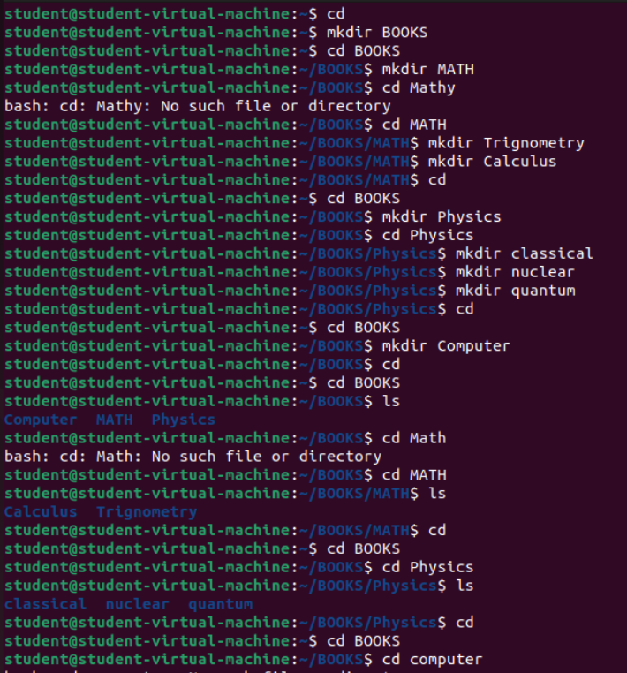

**Task 2:**

Now you are in your home directory. How will you go to chemistry directory directly?

What do you think books/chemistry is relative or absolute path?

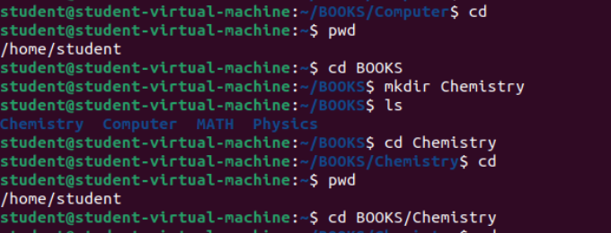

Books/Chemistry Is **Relative Path** as the path doesn’t start with root directory.

**Task 3:**

How will you add a directory graphics under the directory computer while you are in physics’

subdirectory classical?

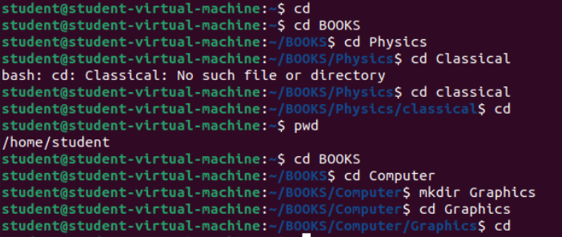

**Task 4:**

You are in books directory, from here try to remove sub-directory quantum under the directory physics.

Now move to directory computer, from here remove sub-directory calculus under the directory math.

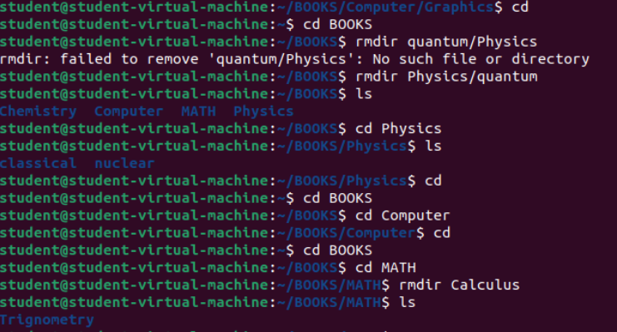

**Task 5:**

Which are the Linux Directory Commands? Explain the understanding of commands in your own words.

|  |  |
| --- | --- |
| **Commands** | **Functions** |
| pwd | It shows the path of a current directory. |
| ls | It shows the subdirectories present in the current directory. |
| ls –a | It uses to show all hidden and unhidden directories. It shows only name of the directories. |
| ls –l | It is used to show details (creation date, name, etc) of a directory. |
| ls –r | It is used to show details (creation date, name, etc) of a directory in a reverse order. |
| cd | It is used to change the directory. E.g., If we write cd Downloads, then it will go to Downloads. |
| ls –l –r | If we want a detail about directory also in reverse order then we use this command. |
| cd .. | It uses to go back to the parent directory from the subdirectory. We will go one directory back. |
| cd / | It uses to go in the root (topmost) directory. |
| cd home | I t will go to just home directory. It will not go to the directory which is automatically created in home. E.g., If we have home/student and we write cd home then it will go to home not in student. |
| cd directory/subdirectory | It will go first in directory then it will go in subdirectory. E.g., Files/files.txt |
| mkdir | Use to make new directory. |
| mkdir directory/subdirectory | Use to make subdirectory in the directory e.g., mkdir Physics/Task1 |
| rmdir | Delete directory which is empty. Means it doen’t have any data or sub directory. |
| rm -r | Delete directory which is not empty. It will have some data or sub directories. |
|  |  |